**Assignment 3: Bluetooth**

* Implementation of protocol is defined by IEEE 802.15 and defined it as a Wireless PAN
* Architecture: There are two types of architecture of Bluetooth.
  + - Piconet
    - Scatternet

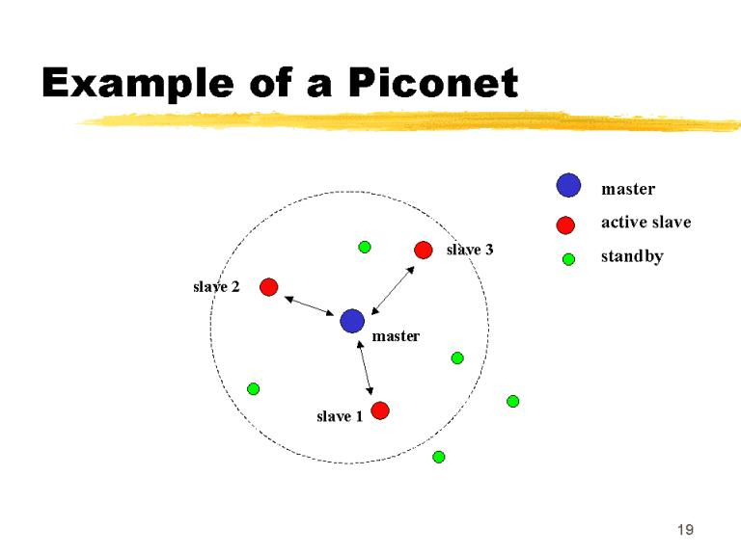

Figure 1: Piconet

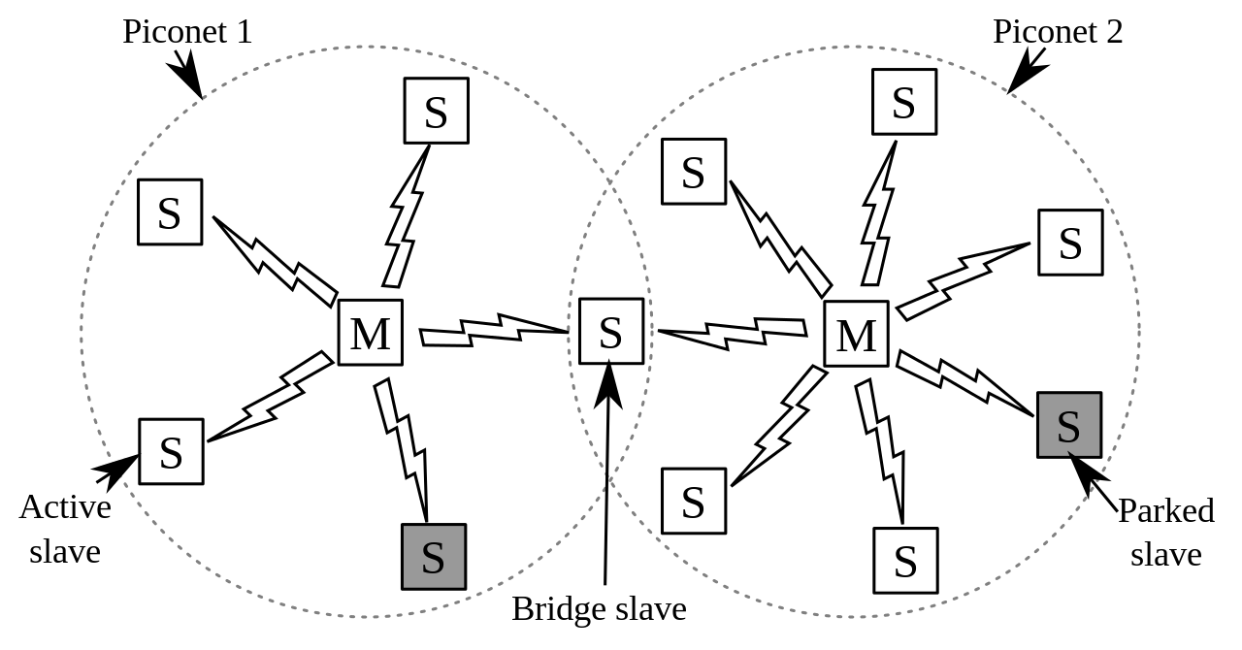

**Protocol Stack:**

The core specification consists of 5 layers:

* **Radio:** Radio **speciﬁes** the **requirements** **for radio transmission** – including **frequency, modulation, and power characteristics** – for a Bluetooth transceiver.
* **Baseband Layer:** It **deﬁnes physical and logical channels and link types** (voice or data); **specﬁes** various **packet formats**, **transmit and receive timing, channel control, and the mechanism for frequency hopping (hop selection) and device addressing**. It specifies point to point or point to multipoint links. **The length of a packet can range from 68 bits (shortened access code) to a maximum of 3071 bits**.
* **LMP- Link Manager Protocol (LMP):** **deﬁnes** the **procedures for link set up and ongoing link management.**
* **Logical Link Control and Adaptation Protocol (L2CAP):** is **responsible** **for adapting upper-layer protocols to the baseband layer.** Used for ACL Link not for SCO Link
* **Service Discovery Protocol (SDP):** allows a Bluetooth device to query other Bluetooth devices for device information, services provided, and the characteristics of those services.

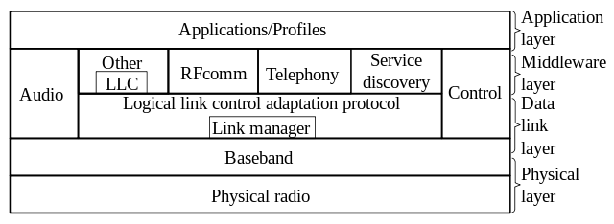

**Bluetooth Communication:**

* Bluetooth **uses 2.4 GHz ISM band** divided into **79 channels of 1MHz each**
* FHSS is used **to avoid interference** from other devices. It hops 1600 times per second, which means **each device changes its modulation frequency 1600 times per second**.
* A device uses a frequency only for **625 microseconds** before it hops to another frequency, that’s called **dwell time**.
* Modulation technique used is **GFSK** and access method is **TDMA/ TDD.**
* **Length of time slots in TDMA = Dwell Time = 625 microsecond**, i.e. During the time that one frequency is used, a sender sends a frame to secondary or a secondary sends a frame to primary.
* In **even Number of slots primary sends the data** and in **odd number of slots secondary sends the data**.
* This method can be termed as Poll Select Method
* The **transmission of data** is done **through a physical link between primary and secondary**, and there are two types of physical links

1. **SCO Links**: Used when **avoiding letancy is more important than integrity**. If a **packet** is **damaged** it is **never transmitted again**. Used **for realtime audio**. **Secondary** can **create upto 3 SCO Link with primary sending digitized audio at 64kbps in each link**
2. **ACL Links**: Used where **integrity is more important than avoiding latency**. **ACL can use 1, 3, or more slots and can achieve a maximum of data rate of 721 kbps**.

**Frame Format**

A frame in baseband layer can be of one of three types:

1 slot

3 slot

5 slot

In any kind of frame one slot is of 625 microsecond out of which 259 microsecond is required for hopping and control mechanism. One slot frame can last only 366 microsecond. With a MHz bandwidth and 1bit/Hz the size of one slot frame is 366bits

